**Restaurant Management System**

Submitted to

**Rezwan Ahmed**

**By**

**Sohel, Saiful Islam (17-35895-3),**

**Chowa, Sinthia (17-33743-1),**

**Saha, Dip Kumar (17-35454-3),**

**Sanjida, Rifat (17-35045-2)**

**Introduction to Database**

**(CSC 2208)**

**American International University – Bangladesh (AIUB)**

**Table of Contents**

Overview of the Business Environment and Project Objectives ........................................................3

Entity Relationship Diagram................................................................................................................4

Normalization .....................................................................................................................................5

Table Descriptions..............................................................................................................................13

Tables with Data ...............................................................................................................................15

SQL Queries .......................................................................................................................................17

Summary ...........................................................................................................................................20

**Overview of the Business Environment and Project Objectives**

In many popular restaurants, employees remain busy whole day. For this reason, they tend to miss the customer or table’s call even booking is sometimes goes wrong. Hence, the goal of this project is to create a database system, which can solve the above issues and manage everything efficiently. The database management system contains customer details, employee details, information about ordering food and tables which will decrease the mistakes of a restaurant management and also it can monitor the workflow of an employee to ensure proper management. Therefore, the objectives are to enhance the efficiency of the restaurant

**Entity Relationship Diagram:**

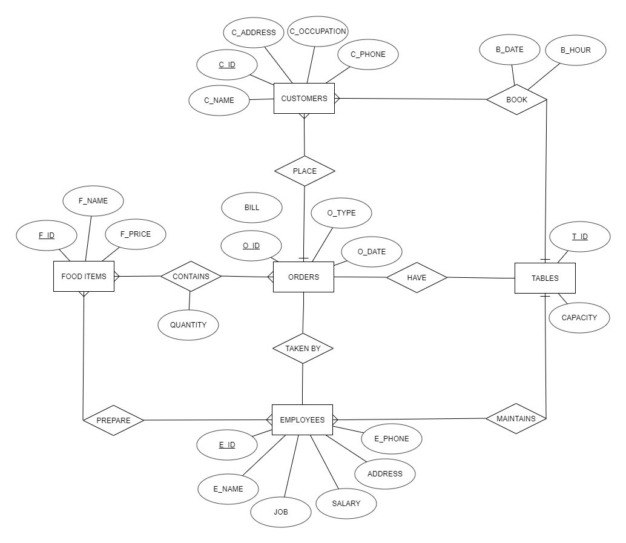

**Normalization:**

**Relation: BOOKING**

|  |  |  |  |  |  |  |  |  |
| --- | --- | --- | --- | --- | --- | --- | --- | --- |
| C_ID | C_NAME | C_OCCUPATION | C_ADDRESS | C_PHONE | B_DATE | B_HOUR | T_ID | CAPACITY |

**1st NF:**

|  |  |  |  |  |  |  |  |  |
| --- | --- | --- | --- | --- | --- | --- | --- | --- |
| C_ID | C_NAME | C_OCCUPATION | C_ADDRESS | C_PHONE | B_DATE | B_HOUR | T_ID | CAPACITY |

**2ND NF:**

Customers

|  |  |  |  |  |
| --- | --- | --- | --- | --- |
| C_ID | C_NAME | C_OCCUPATION | C_ADDRESS | C_PHONE |

Booking

|  |  |  |  |
| --- | --- | --- | --- |
| C_ID | T_ID | B_HOUR | B_DATE |

Table

|  |  |
| --- | --- |
| T_ID | CAPACITY |

**3rd NF:**

Customers

|  |  |  |  |  |
| --- | --- | --- | --- | --- |
| C_ID | C_NAME | C_OCCUPATION | C_ADDRESS | C_PHONE |

Booking

|  |  |  |  |
| --- | --- | --- | --- |
| C_ID | T_ID | B_HOUR | B_DATE |

Tables

|  |  |
| --- | --- |
| T_ID | CAPACITY |

**Relation: Place**

|  |  |  |  |  |  |  |  |  |
| --- | --- | --- | --- | --- | --- | --- | --- | --- |
| C_ID | C_NAME | C_OCCUPATION | C_ADDRESS | C_PHONE | O_ID | O_TYPE | O_DATE | BILL |

**1ST NF:**

|  |  |  |  |  |  |  |  |  |
| --- | --- | --- | --- | --- | --- | --- | --- | --- |
| C_ID | C_NAME | C_OCCUPATION | C_ADDRESS | C_PHONE | O_ID | O_TYPE | O_DATE | BILL |

**2ND NF:**

Customers

|  |  |  |  |  |
| --- | --- | --- | --- | --- |
| C_ID | C_NAME | C_OCCUPATION | C_ADDRESS | C_PHONE |

Orders

|  |  |  |  |  |
| --- | --- | --- | --- | --- |
| O_ID | O_TYPE | O_DATE | BILL | C_ID |

3**rd NF:**

Customers

|  |  |  |  |  |
| --- | --- | --- | --- | --- |
| C_ID | C_NAME | C_OCCUPATION | C_ADDRESS | C_PHONE |

Orders

|  |  |  |  |  |
| --- | --- | --- | --- | --- |
| O_ID | O_TYPE | O_DATE | BILL | C_ID |

**Relation: Have**

|  |  |  |  |  |  |
| --- | --- | --- | --- | --- | --- |
| T_ID | CAPACITY | O_ID | O_TYPE | O_DATE | BILL |

**1ST NF**

|  |  |  |  |  |  |
| --- | --- | --- | --- | --- | --- |
| T_ID | CAPACITY | O_ID | O_TYPE | O_DATE | BILL |

**2ND NF:**

Tables

|  |  |
| --- | --- |
| T_ID | CAPACITY |

Orders

|  |  |  |  |
| --- | --- | --- | --- |
| O_ID | O_TYPE | O_DATE | BILL |

Order_history

|  |  |
| --- | --- |
| T_ID | O_ID |

**3RD NF:**

Tables

|  |  |
| --- | --- |
| T_ID | CAPACITY |

Orders

|  |  |  |  |
| --- | --- | --- | --- |
| O_ID | O_TYPE | O_DATE | BILL |

Order_history

|  |  |
| --- | --- |
| T_ID | O_ID |

**Relation: Taken by**

|  |  |  |  |  |  |  |  |  |  |
| --- | --- | --- | --- | --- | --- | --- | --- | --- | --- |
| O_ID | O_TYPE | O_DATE | BILL | E_ID | E_NAME | JOB | SALARY | ADDRESS | E_PHONE |

**1ST NF:**

|  |  |  |  |  |  |  |  |  |  |
| --- | --- | --- | --- | --- | --- | --- | --- | --- | --- |
| O_ID | O_TYPE | O_DATE | BILL | E_ID | E_NAME | JOB | SALARY | ADDRESS | E_PHONE |

**2ND NF:**

Orders

|  |  |  |  |  |
| --- | --- | --- | --- | --- |
| O_ID | O_TYPE | O_DATE | BILL | E_ID |

**Employees**

|  |  |  |  |  |  |
| --- | --- | --- | --- | --- | --- |
| E_ID | E_NAME | JOB | SALARY | ADDRESS | E_PHONE |

**3RD NF:**

Orders

|  |  |  |  |  |
| --- | --- | --- | --- | --- |
| O_ID | O_TYPE | O_DATE | BILL | E_ID |

**Employees**

|  |  |  |  |  |  |
| --- | --- | --- | --- | --- | --- |
| E_ID | E_NAME | JOB | SALARY | ADDRESS | E_PHONE |

**Relation: Contain**

|  |  |  |  |  |  |  |  |
| --- | --- | --- | --- | --- | --- | --- | --- |
| O_ID | O_TYPE | O_DATE | BILL | F_ID | F_NAME | F_PRICE | QUANTITY |

**1ST NF:**

|  |  |  |  |  |  |  |  |
| --- | --- | --- | --- | --- | --- | --- | --- |
| O_ID | O_TYPE | O_DATE | BILL | F_ID | F_NAME | F_PRICE | QUANTITY |

**2nd NF:**

Orders

|  |  |  |  |
| --- | --- | --- | --- |
| O_ID | O_TYPE | O_DATE | BILL |

Foods

|  |  |  |
| --- | --- | --- |
| F_ID | F_NAME | F_PRICE |

Items

|  |  |  |
| --- | --- | --- |
| O_ID | F_ID | QUANTITY |

**3rd NF:**

Orders

|  |  |  |  |
| --- | --- | --- | --- |
| O_ID | O_TYPE | O_DATE | BILL |

Foods

|  |  |  |
| --- | --- | --- |
| F_ID | F_NAME | F_PRICE |

Items

|  |  |  |
| --- | --- | --- |
| O_ID | F_ID | QUANTITY |

**Relation: Maintain**

|  |  |  |  |  |  |  |  |
| --- | --- | --- | --- | --- | --- | --- | --- |
| E_ID | E_NAME | JOB | SALARY | ADDRESS | E_PHONE | T_ID | CAPACITY |

**1ST NF:**

|  |  |  |  |  |  |  |  |
| --- | --- | --- | --- | --- | --- | --- | --- |
| E_ID | E_NAME | JOB | SALARY | ADDRESS | E_PHONE | T_ID | CAPACITY |

**2ND NF:**

**Employees**

|  |  |  |  |  |  |
| --- | --- | --- | --- | --- | --- |
| E_ID | E_NAME | JOB | SALARY | ADDRESS | E_PHONE |

Tables

|  |  |  |
| --- | --- | --- |
| T_ID | CAPACITY | E_ID |

**3RD NF:**

**Employees**

|  |  |  |  |  |  |
| --- | --- | --- | --- | --- | --- |
| E_ID | E_NAME | JOB | SALARY | ADDRESS | E_PHONE |

Tables

|  |  |  |
| --- | --- | --- |
| T_ID | CAPACITY | E_ID |

**Relation: Prepare**

|  |  |  |  |  |  |  |  |  |
| --- | --- | --- | --- | --- | --- | --- | --- | --- |
| E_ID | E_NAME | JOB | SALARY | ADDRESS | E_PHONE | F_ID | F_NAME | F_PRICE |

**1ST NF:**

|  |  |  |  |  |  |  |  |  |
| --- | --- | --- | --- | --- | --- | --- | --- | --- |
| E_ID | E_NAME | JOB | SALARY | ADDRESS | E_PHONE | F_ID | F_NAME | F_PRICE |

**2ND NF:**

**Employees**

|  |  |  |  |  |  |
| --- | --- | --- | --- | --- | --- |
| E_ID | E_NAME | JOB | SALARY | ADDRESS | E_PHONE |

Foods

|  |  |  |  |
| --- | --- | --- | --- |
| F_ID | F_NAME | F_PRICE | E_ID |

**3RD NF:**

**Employees**

|  |  |  |  |  |  |
| --- | --- | --- | --- | --- | --- |
| E_ID | E_NAME | JOB | SALARY | ADDRESS | E_PHONE |

Foods

|  |  |  |  |
| --- | --- | --- | --- |
| F_ID | F_NAME | F_PRICE | E_ID |

**Normalized tables:**

Employees

|  |  |  |  |  |  |
| --- | --- | --- | --- | --- | --- |
| E_ID | E_NAME | JOB | SALARY | ADDRESS | E_PHONE |

Customers

|  |  |  |  |  |
| --- | --- | --- | --- | --- |
| C_ID | C_NAME | C_OCCUPATION | C_ADDRESS | C_PHONE |

Foods

|  |  |  |  |
| --- | --- | --- | --- |
| F_ID | F_NAME | F_PRICE | E_ID |

Tables

|  |  |  |
| --- | --- | --- |
| T_ID | CAPACITY | E_ID |

Orders

|  |  |  |  |  |  |
| --- | --- | --- | --- | --- | --- |
| O_ID | O_TYPE | O_DATE | BILL | C_ID | E_ID |

Items

|  |  |  |
| --- | --- | --- |
| O_ID | F_ID | QUANTITY |

Order_history

|  |  |
| --- | --- |
| T_ID | O_ID |

Booking

|  |  |  |  |
| --- | --- | --- | --- |
| C_ID | T_ID | B_HOUR | B_DATE |

**Description of Tables**

**Employee:**

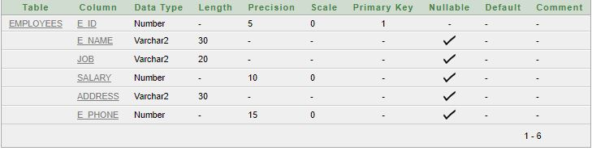

**Customers:**

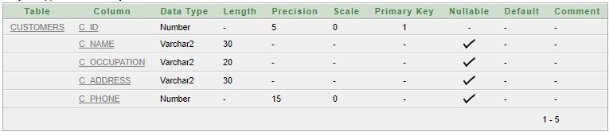

**Foods:**

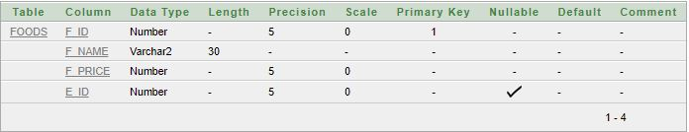

**Tables:**

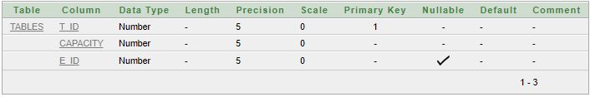

**Orders:**

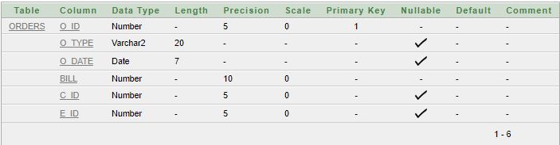

**Items:**

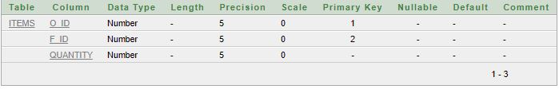

**Order_history:**

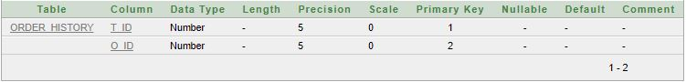

**Booking:**

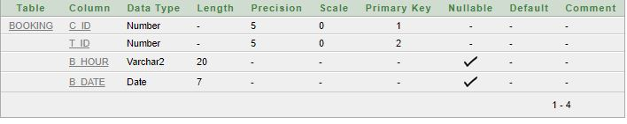

**Table with Data**

**Employees:**

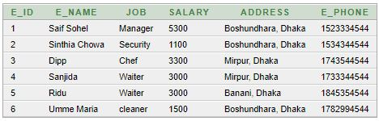

**Customers:**

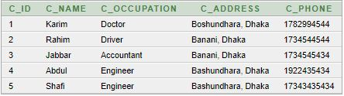

**Foods:**

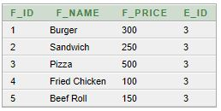

**Tables:**

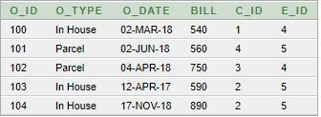

**Items:**

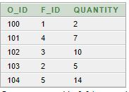

**Oreder_history:**

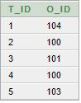

**Booking:**

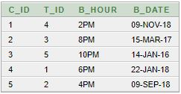

**QUERY**

1. Show employees whose salary is more than 3000

Ans: select * from employees where salary>3000

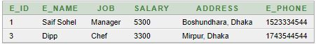

1. Show maximum salary from table employee.

Ans: select max(salary) from employees



1. Show the number of employees whose job is waiter.

Ans: select count(*) from employees where job = 'Waiter'.



1. Show the employee who maintains table 4.

Ans: select employees.* from employees, tables where employees.e_id = tables.e_id and t_id = 4



1. Show the employees whose salary is greater than ‘Sanjida’.

Ans: select e.* from employees e, employees s where s.e_name = 'Sanjida' and e.salary>s.salary

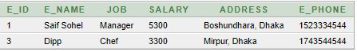

1. Show the ordered which is ordered first

Ans: select * from orders where o_date = (select min(o_date) from orders)



1. Show the foods which is more pricier than ‘Sandwich’

Ans: select a.* from foods a, foods b where b.f_name = 'Sandwich' and a.f_price>b.f_price

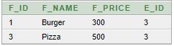

1. Show the foods prepared by employee ‘Chef’

Ans: select foods.* from foods, employees where foods.e_id = employees.e_id and employees.job = 'Chef'

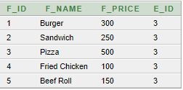

1. Show the customers who ordered for ‘Parcel’.

Ans: select customers.* from customers, orders where customers.c_id = orders.c_id and orders.o_type = 'Parcel'

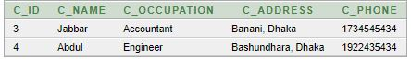

1. Show the employees who do the same job as ‘Ridu’.

Ans: select a.* from employees a, employees b where b.e_name = 'Ridu' and a.job = b.job

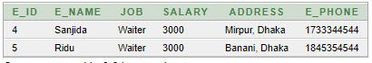

**Summary**

The first problem that we faced while doing the projects is to select the topic with a lots of brain storming, we select to create a database management system on restaurant management. Then while doing ER-diagram we could not able to make the relations among entity sets and we faced many problems in normalization. However, after revising class notes and slides we overcame our problems and able to complete the project. We did not face much issue on the query as we practiced a lot in the lab classes. Though, we had to work hard on this project, we have learned a lot about what types of problems we have to face when creating a database management system and how to overcome them.